**Exercise 1:**

<html>

<head>

<title> "My First HTML Page"</title>

<h1> My name is Roshini P</h1>

<p>About my hobbies I like to listen to music learn the lyrics of the song <br> Surfing on internet like to learn new technologies and reading books</p>

<hr>

<br>

</head>

</html>

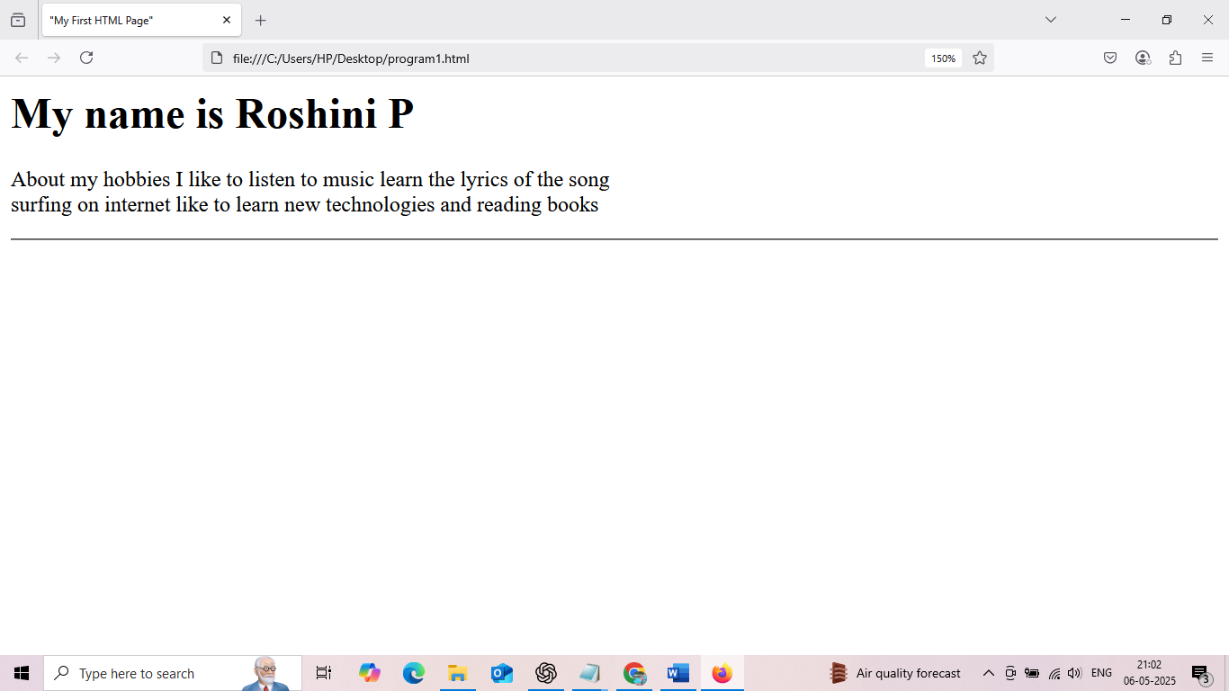

**Exercise 2:**

<html>

<head>

<title> Lists and Links</title>

</head>

<body>

<h4>My favourite fruits</h4>

<ul>

<li>Mango</li>

<li>Orange</li>

<li>Banana</li>

</ul>

<h4>Top 3 Movies</h4>

<ol>

<li>The Dark Knight</li>

<li>3 Idiots</li>

<li>PK</li>

</ol>

<a href="https://www.google.com" target="_blank">My favourite website</a>

</body>

</html>

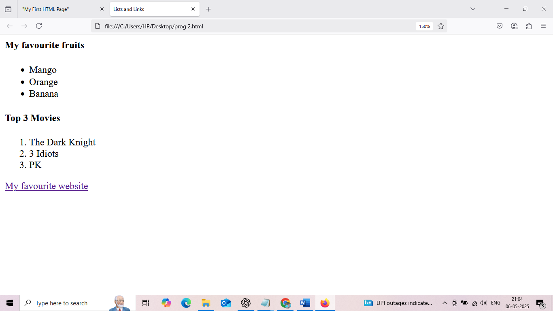



**Exercise 3:**

<html>

<head>

<title>Adding images and tables</title>

</head>

<body>

<h3>Adding image</h3>

<img src="C:/Users/HP/Desktop/picture/scene.jpg" alt="scene"></img>

<h3>Student tables</h3>

<table>

<tr>

<th>Student Name</th>

<th>Age</th>

<th>Favorite Subject</th>

</tr>

<tr>

<td>Dravid</td>

<td>12</td>

<td>Math</td>

</tr>

<tr>

<td>Elly</td>

<td>15</td>

<td>Physics</td>

</tr>

<tr>

<td>Navya</td>

<td>18</td>

<td>computer Science</td>

</tr>

</body>

</html>

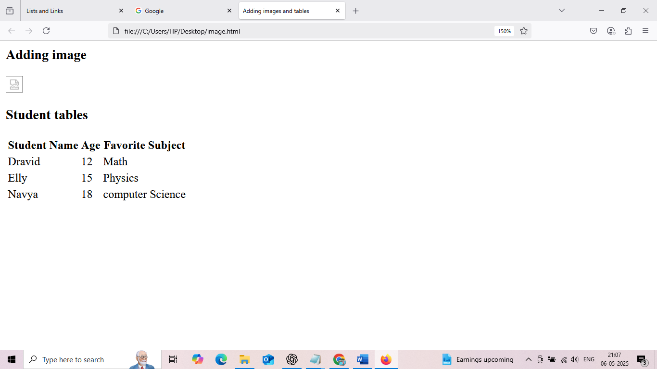

**Exercise 4:**

<html>

<head>

<title> Intro to css</title>

<style>

h3 {

background-color: lightblue;

color: darkblue;

font-size: 30px;

}

p {

font-family: Arial,sans-serif;

text-align: justify;

}

table, th,td {

border: 1px solid black;

border-collapse: collapse;

padding: 8px;

}

</style>

</head>

<body>

<h3>Welcome to css styling</h3>

<p>

CSS is used to style and layout web pages. <br> It allows to apply colors,fonts,spacing and positioning to HTML elements<br> Using internal css, we can define styles directly within the HTMl document.

</p>

</body>

</html>

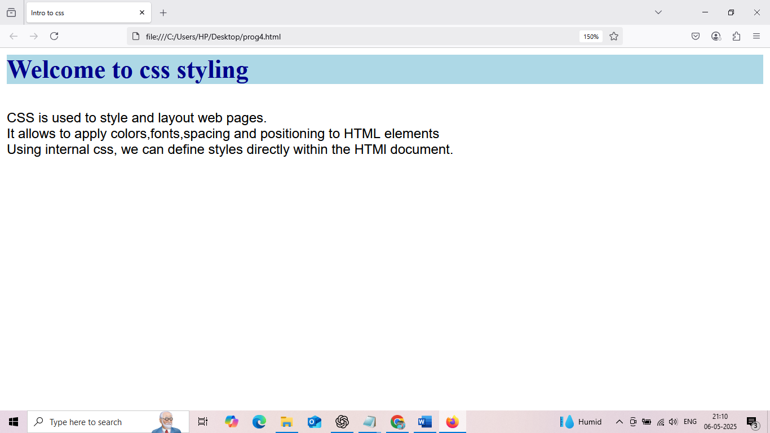

**Exercise 5:**

<html>

<head>

<title> div styling </title>

<style>

#intro {

border: 2px solid black;

padding : 15px;

margin-bottom: 20px;

}

.highlight{

background-color: orange;

padding: 10px;

}

</style>

</head>

<body>

<div id="intro">

<h3>Introduction</h3>

<p>This is introduction section styled with a border and padding.</p>

</div>

<div class="highlight">

<h2>Highlight section</h2>

<p>This is has blue background with is sed as highlight.</p>

</div>

</body>

</html>

